**Homework 13**

**Task 1.1**

**Bug reports**

| Issue type | bug report 001 |
| --- | --- |
| Summary | The ‘Name” field in the contact form, must not validate special characters, except “-”, “_”, “@”, “.” |
| Environment | Mac OS Chrome |
| Steps to reproduce | 1. Go to <https://www.headhunterhairstyling.com/contact> 2. Fill in the ‘Name” field in the contact form with special characters 3. Fill in other required fields 4. Press “send” button |
| Actual result | The message is sent |
| Expected result | The system informs user with a message “The ‘Name” field must not contain special characters, except “-”, “_”, “@”, “.” |

| Issue type | bug report 002 |
| --- | --- |
| Summary | The ‘Phone” field in the contact form, must not contain special characters or letters |
| Environment | Mac OS Chrome |
| Steps to reproduce | 1. Go to <https://www.headhunterhairstyling.com/contact> 2. Fill in the ‘Phone” field in the contact form with special characters or letters 3. Fill in other required fields 4. Press “send” button |
| Actual result | The message is sent |
| Expected result | The system informs user with a message “The ‘Phone” field must contain only digits |

| Issue type | bug report 003 |
| --- | --- |
| Summary | The ‘Message” field in the contact form, must not be empty |
| Environment | Mac OS Chrome |
| Steps to reproduce | 1. Go to <https://www.headhunterhairstyling.com/contact> 2. Fill in the required fields in the contact form. 3. Leave “Message” field empty 4. Press “send” button |
| Actual result | The message is sent |
| Expected result | The system informs user with a message “The ‘Message” field in the contact form, must not be empty” |

**Task 1.2**

The HTML files you can find following the link below:

<https://drive.google.com/drive/folders/1Xu5QpZ54E7KrB2T0FLEWDVDR-yCfSXf4?usp=sharing>

The html pages were opened with Chrome and Safari. I could not recognize any difference in the pages displaying.

**Task 2**

[**https://beetroot.academy**](https://beetroot.academy/)

**utf-8**

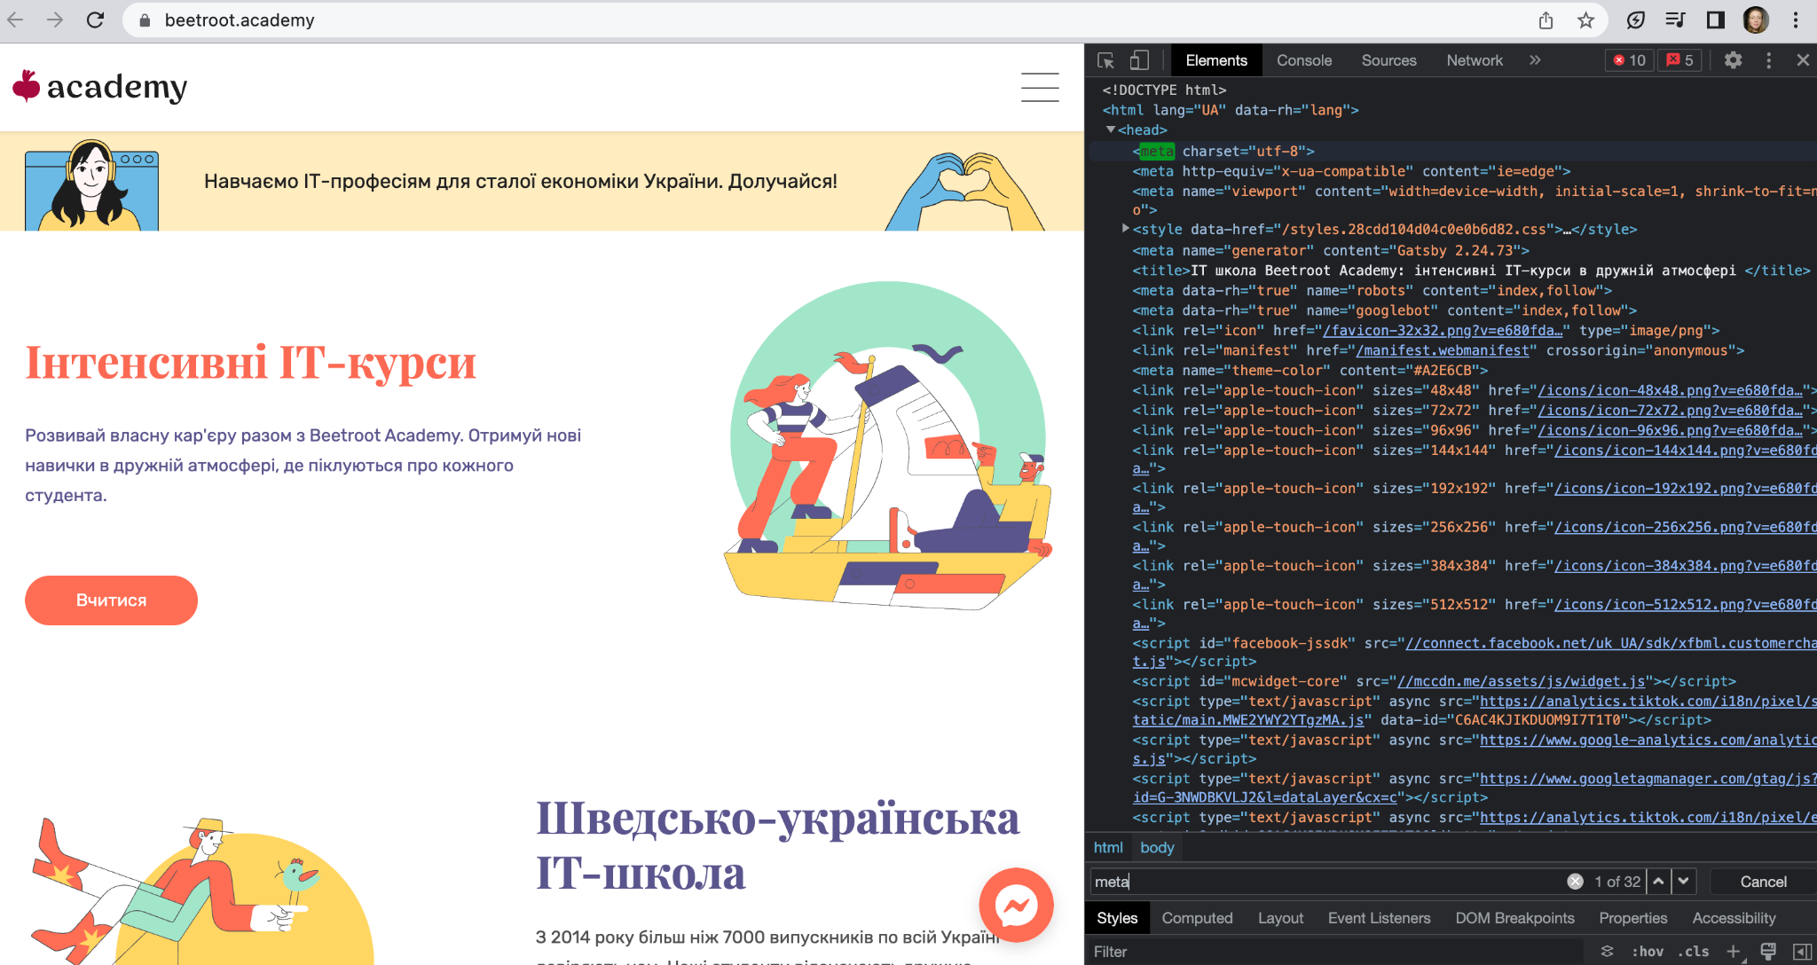

[**https://microseniors76.com/**](https://microseniors76.com/)

**iso-8859-1**

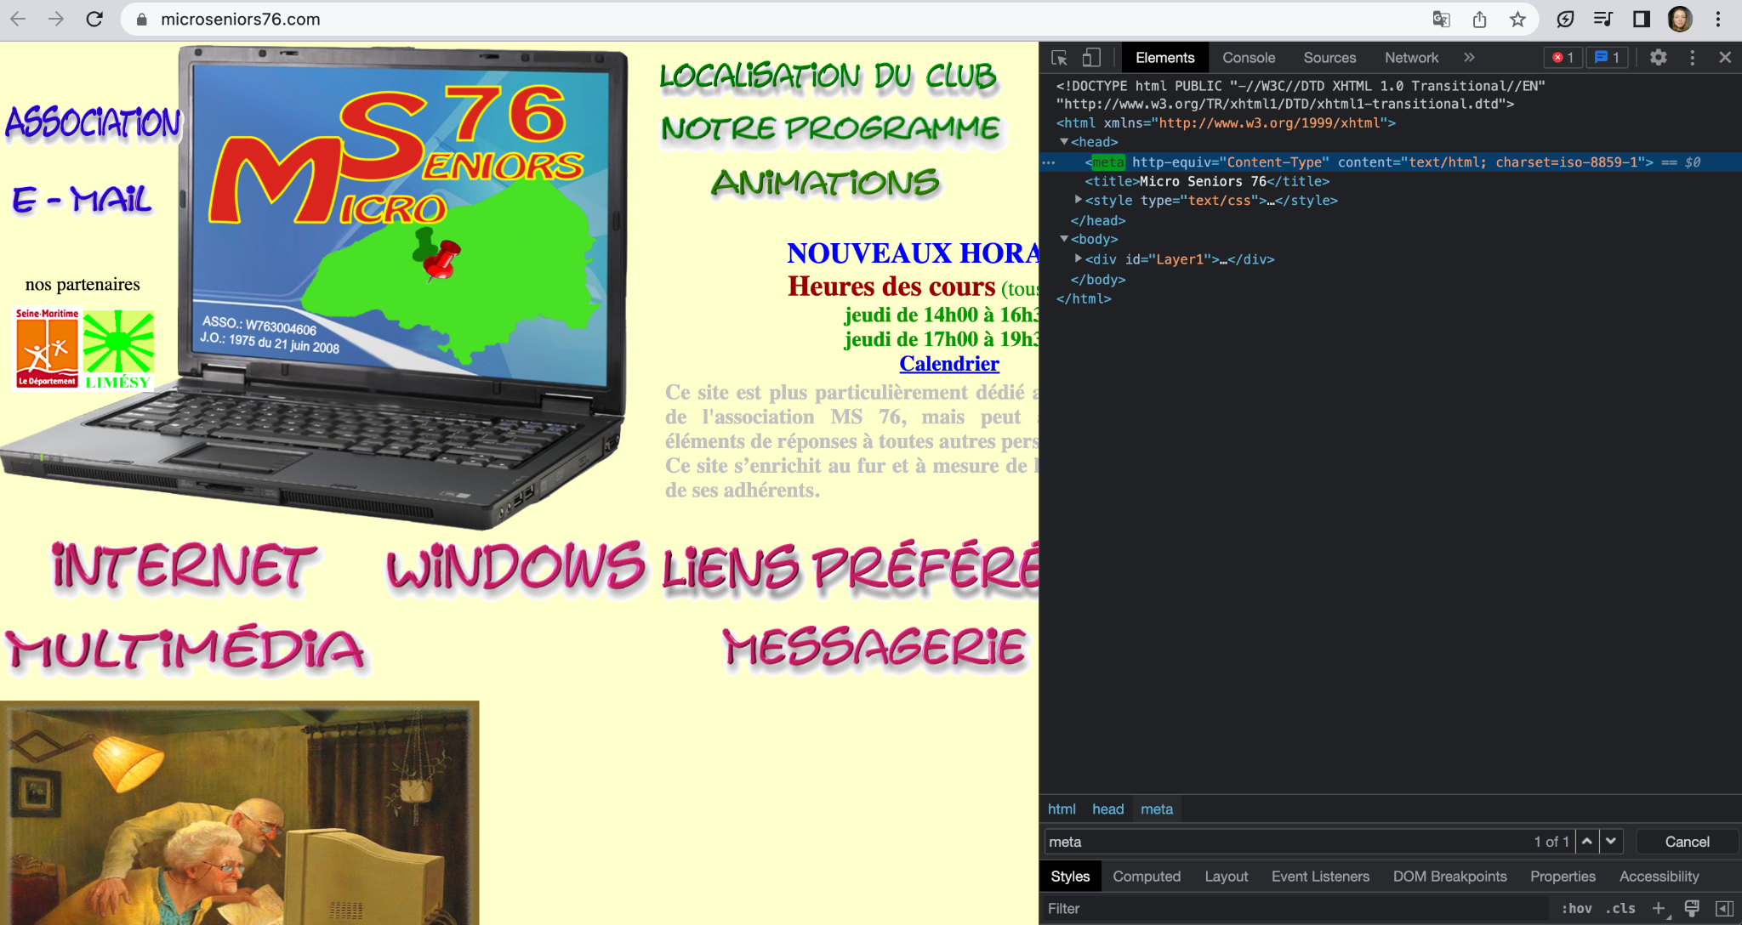

[**https://www.tennis-warehouse.com/**](https://www.tennis-warehouse.com/)

**macintosh**

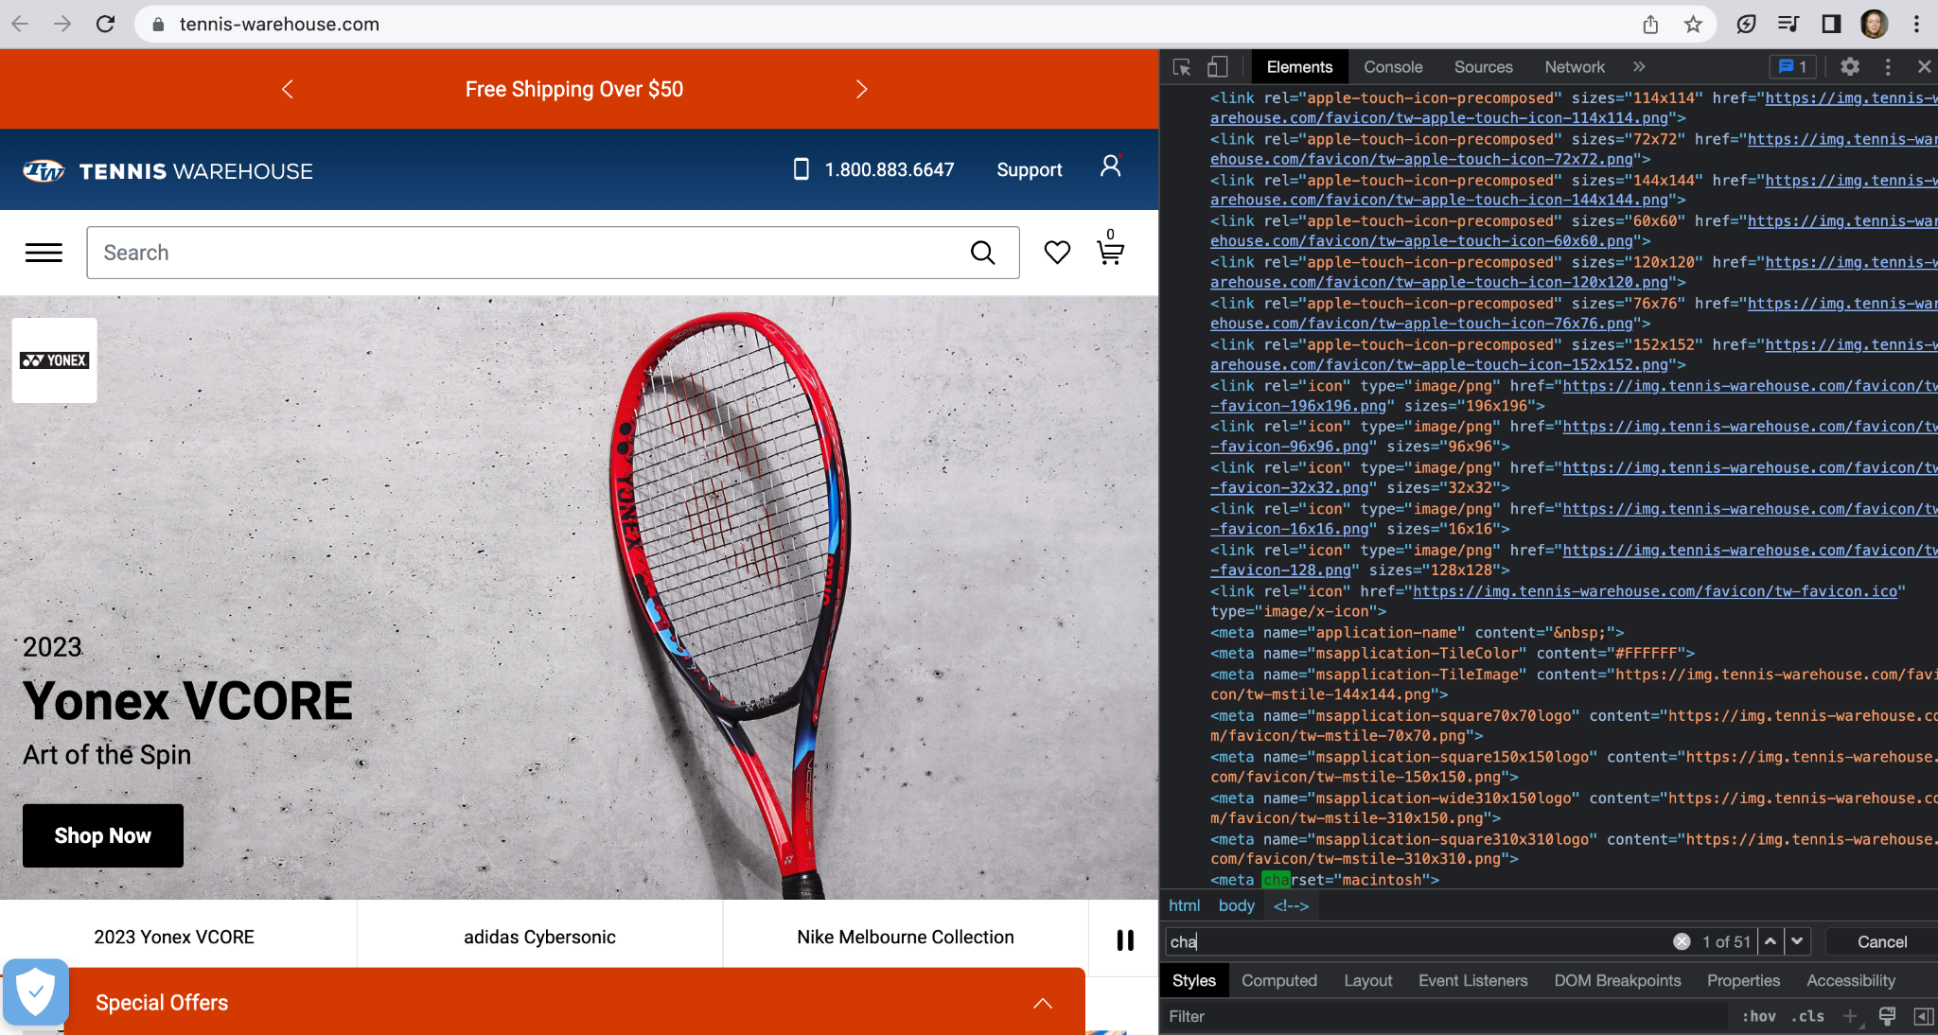

[**https://www.fidelity.com/**](https://www.fidelity.com/)

**iso-8859-1**

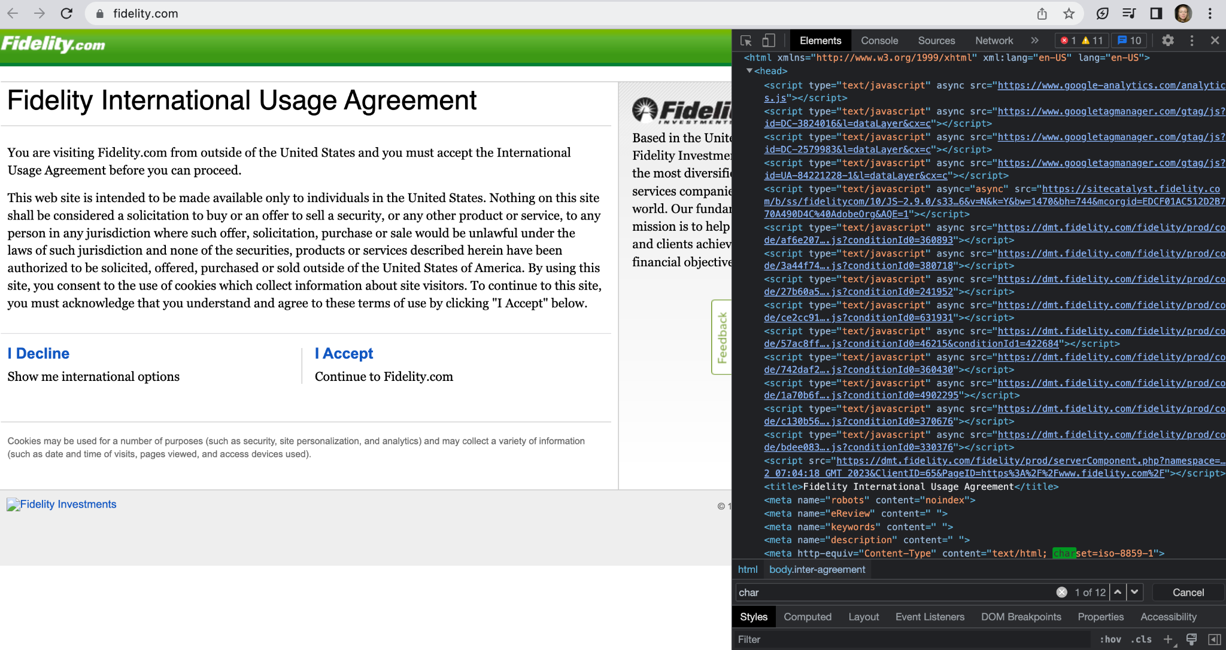

**Task 3**

**Xpath Amazon**

**Logo -**

//a[@id='nav-logo-sprites']

//*[@id="nav-logo-sprites"]

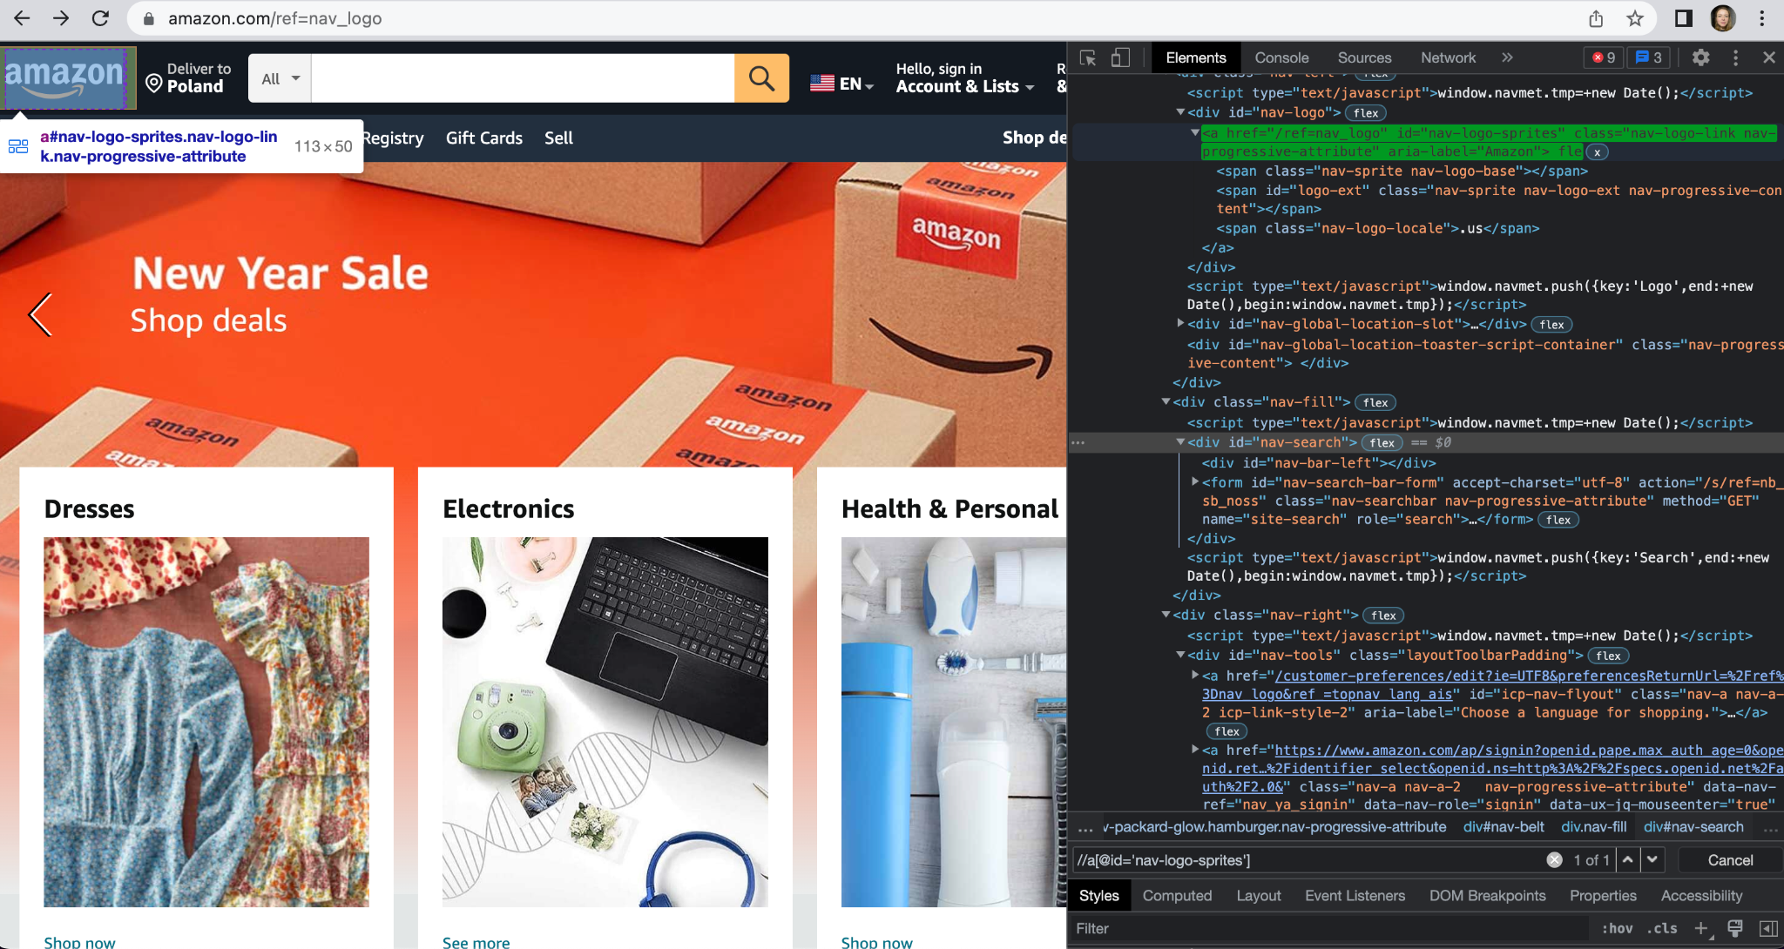

**Cart -**

//a[@id='nav-cart']

//*[@id="nav-cart"]

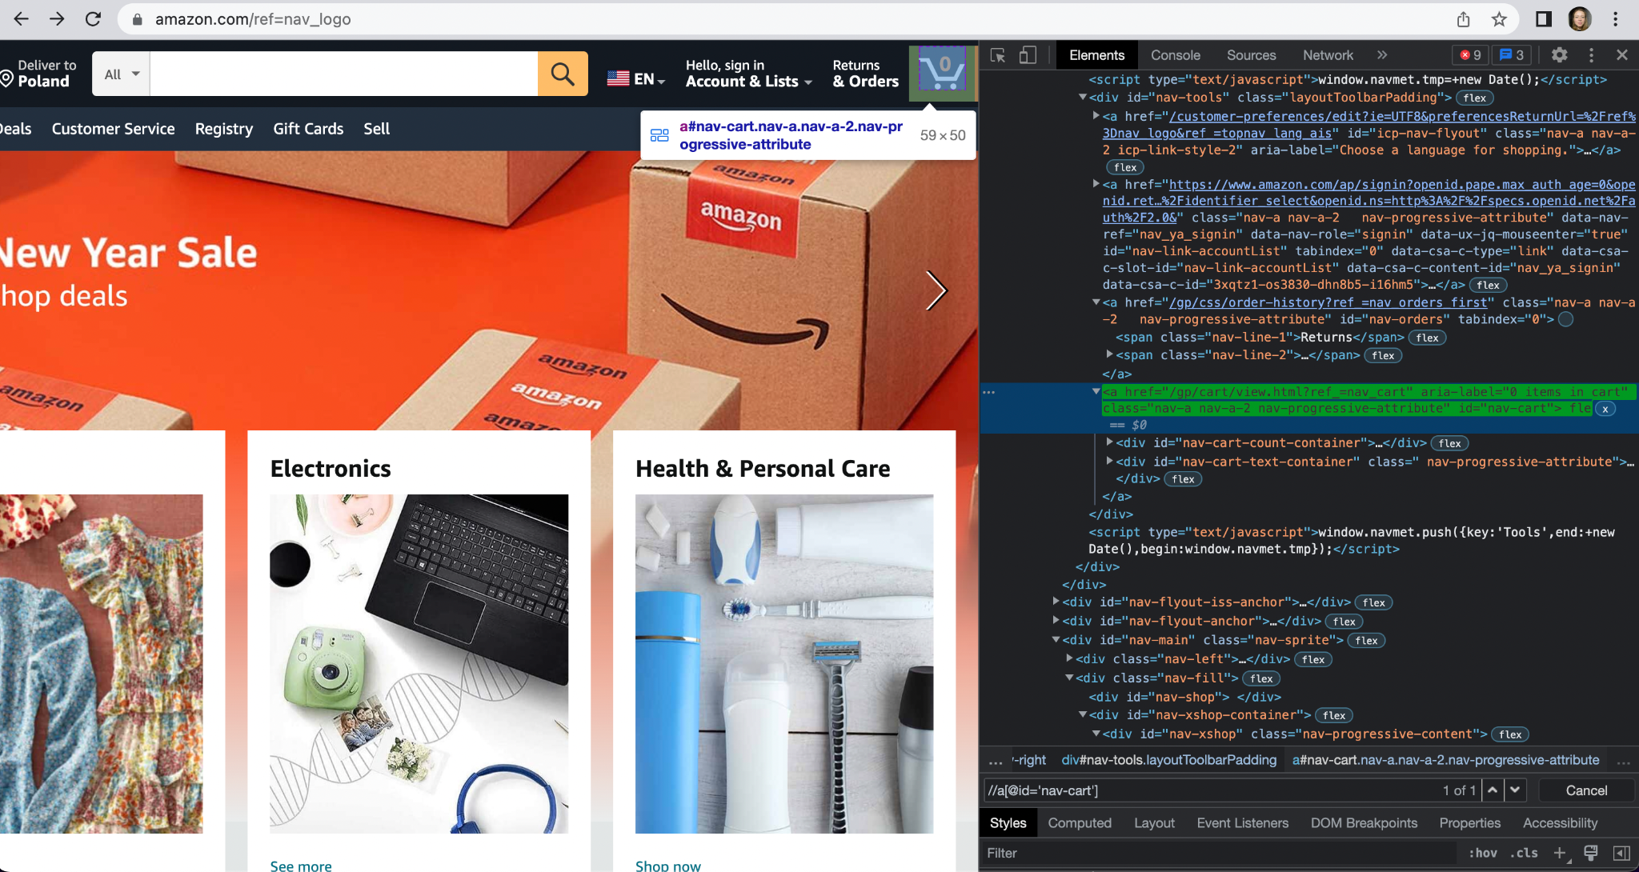

**Language switcher -**

//a[@id='icp-nav-flyout']

//*[@id="icp-nav-flyout"]

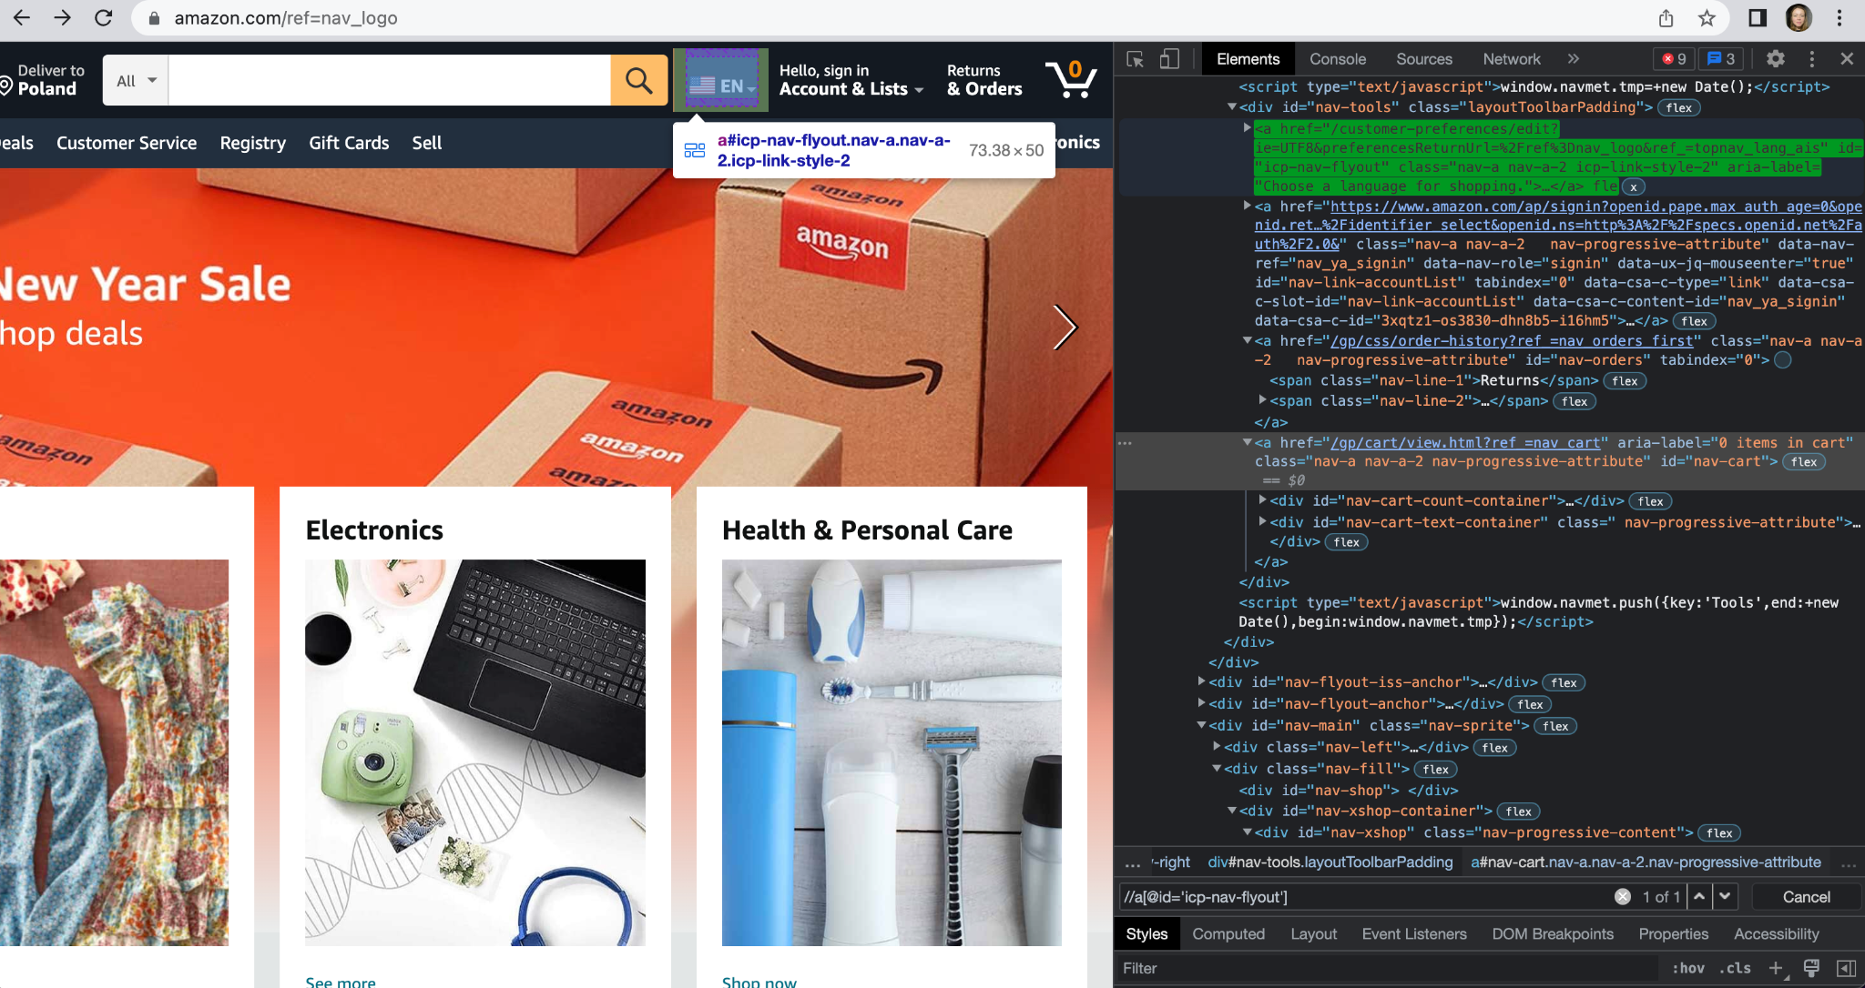

**Search -**

//div[@id='nav-search']

//*[@id="nav-search-keywords"]

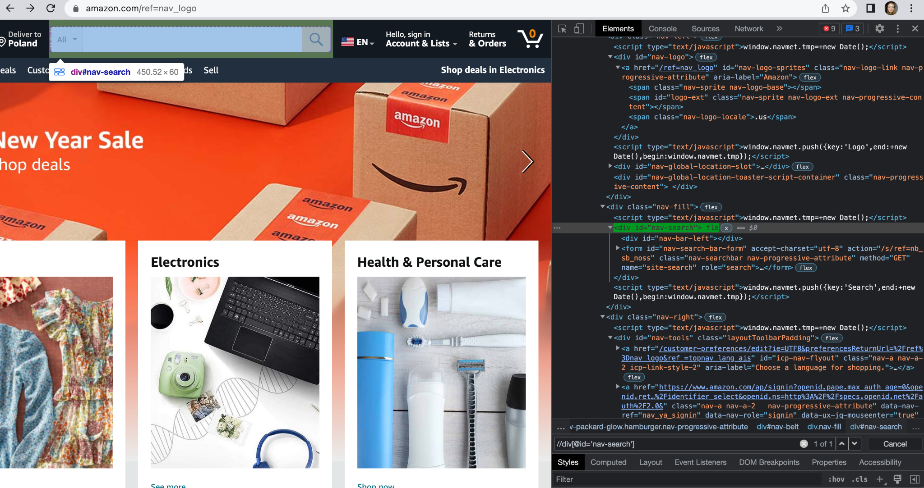

**Gift Cards menu -**

//a[@data-csa-c-slot-id='nav_cs_3']

//*[@id="nav-gwbar"]/a[9]

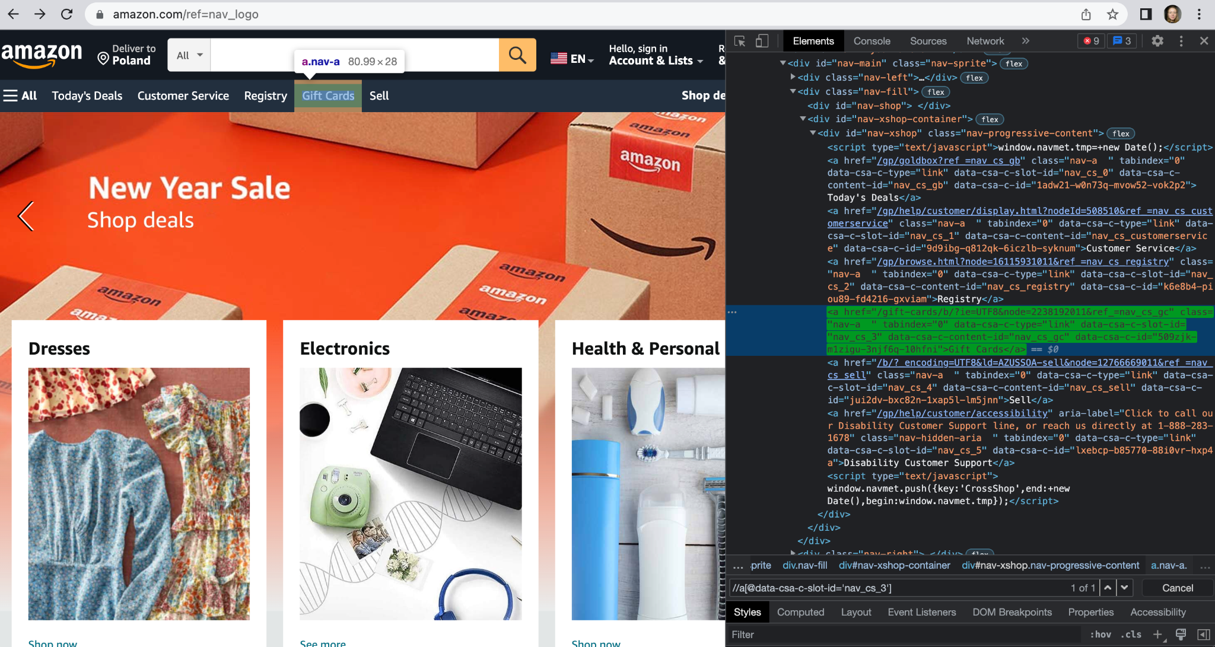

**Today’s deals menu -**

//a[@data-csa-c-content-id='nav_cs_gb']

//*[@id="nav-xshop"]/a[1]

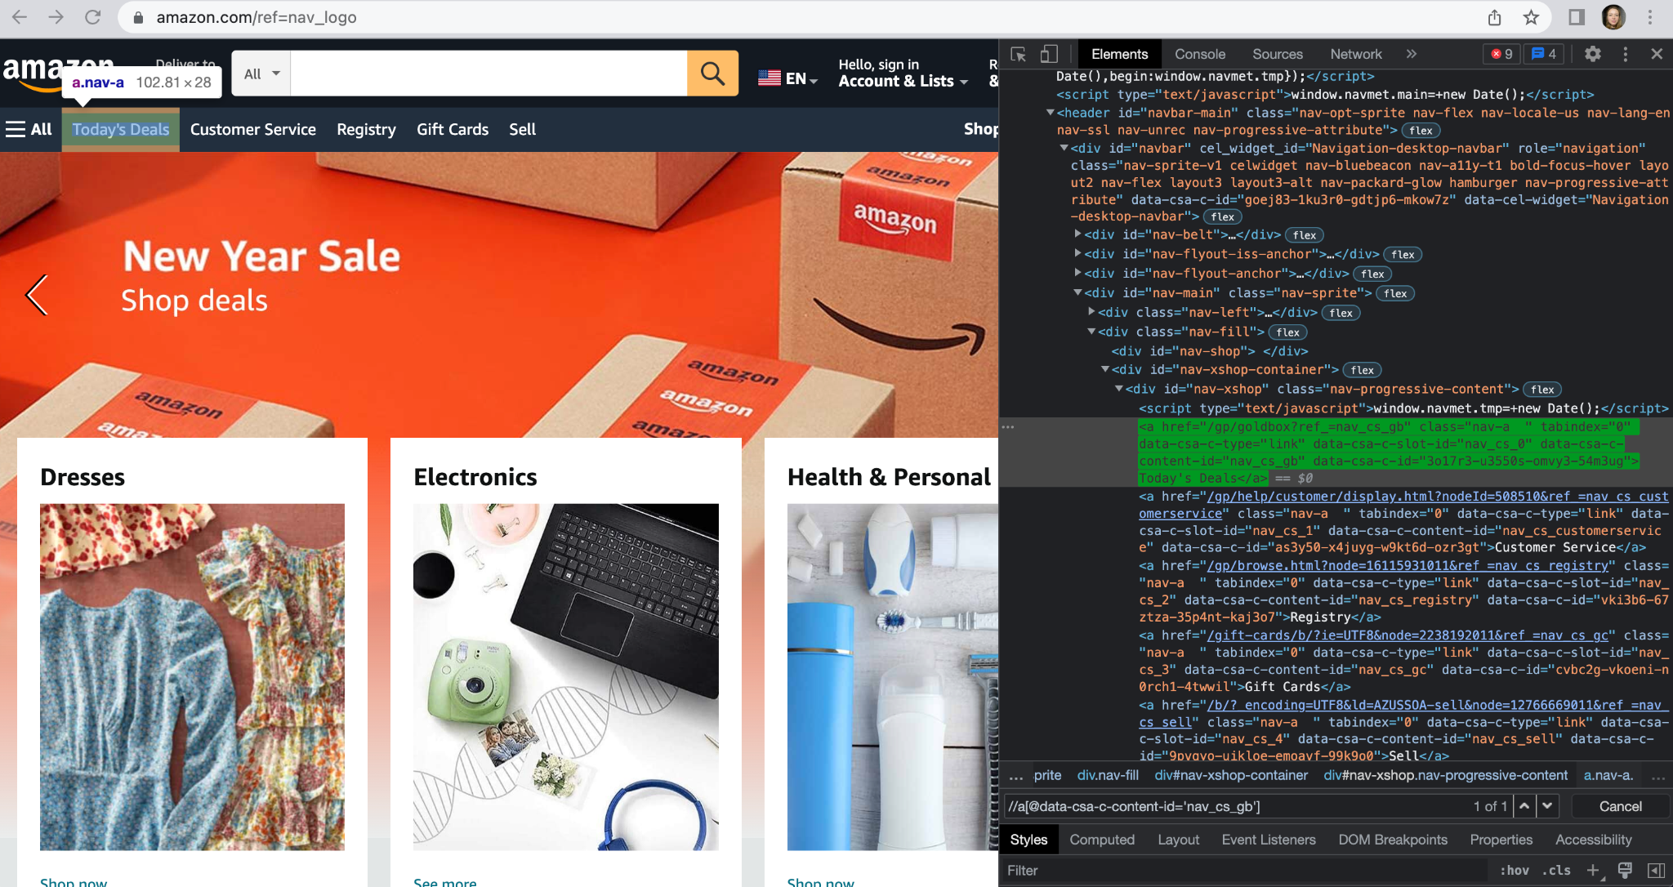

**Registry menu -**

//a[@data-csa-c-content-id='nav_cs_registry']

//*[@id="nav-xshop"]/a[3]

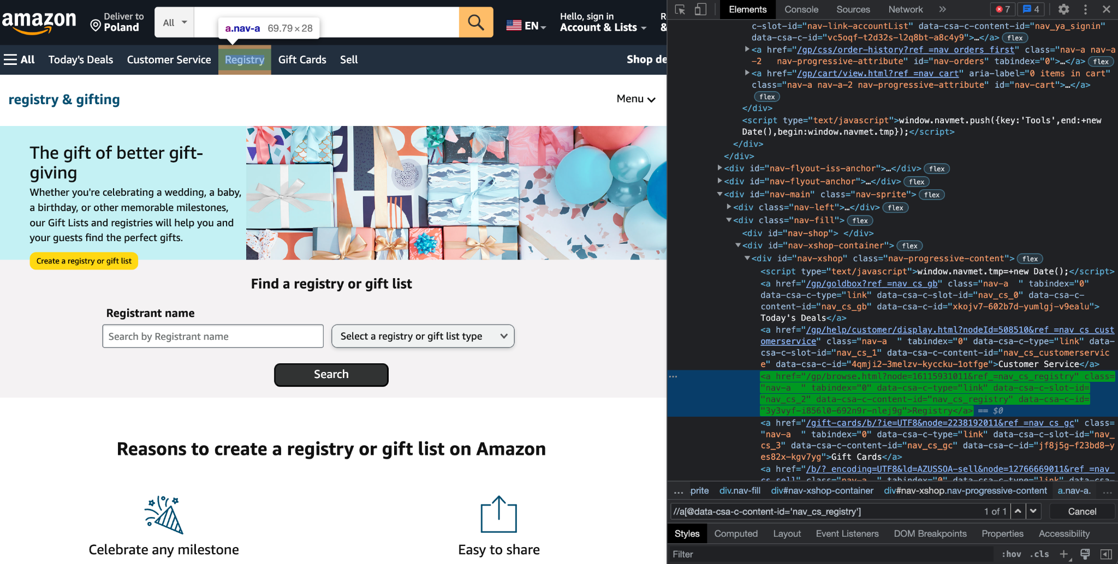

**Sell menu -**

//a[@data-csa-c-content-id='nav_cs_sell']

//*[@id="nav-xshop"]/a[5]

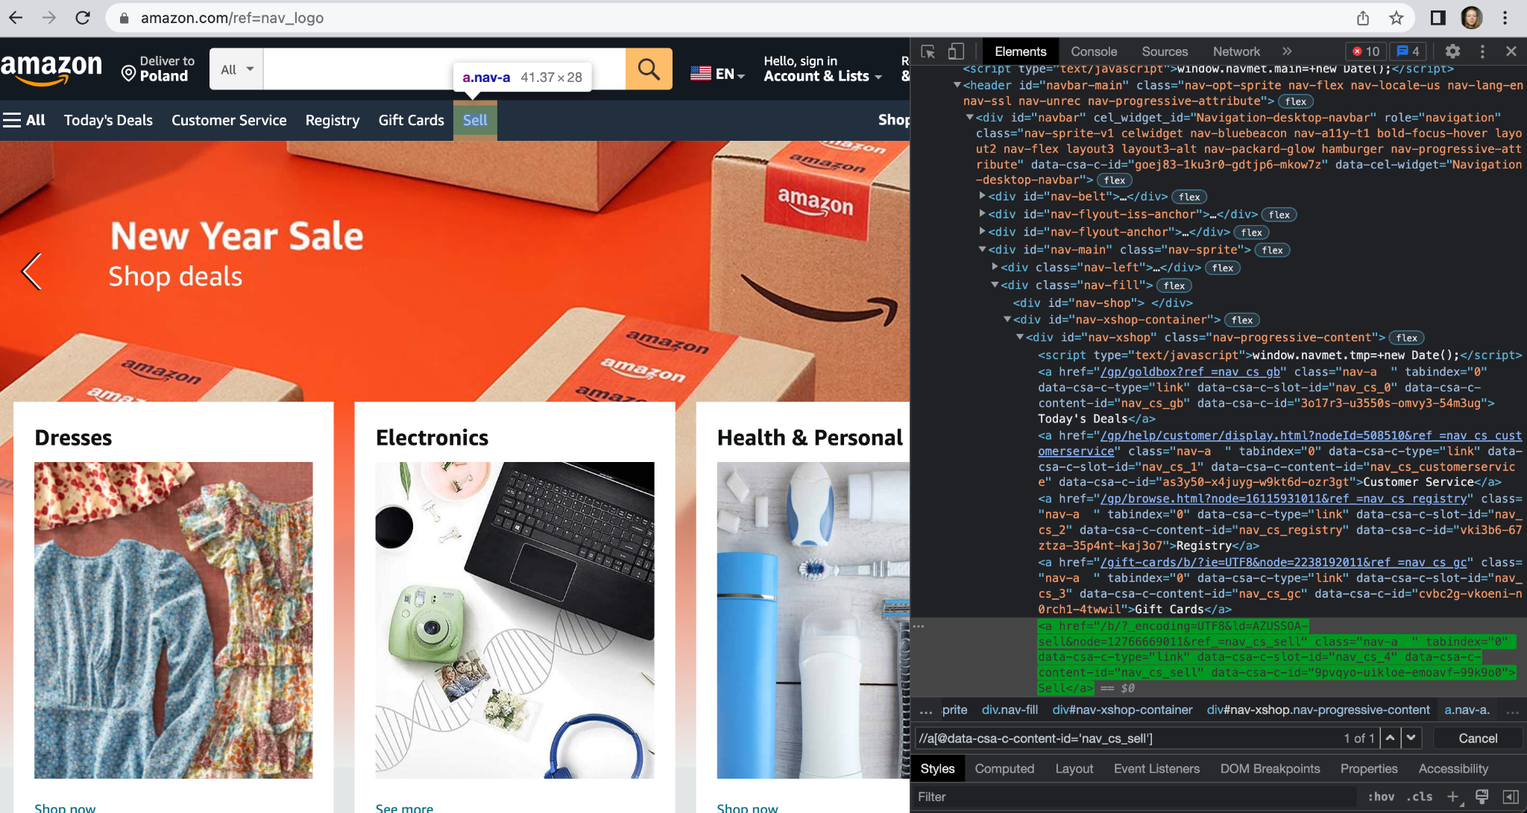

**Accounts & Lists menu -**

//a[@data-csa-c-content-id='nav_ya_signin']

//*[@id="nav-link-accountList"]

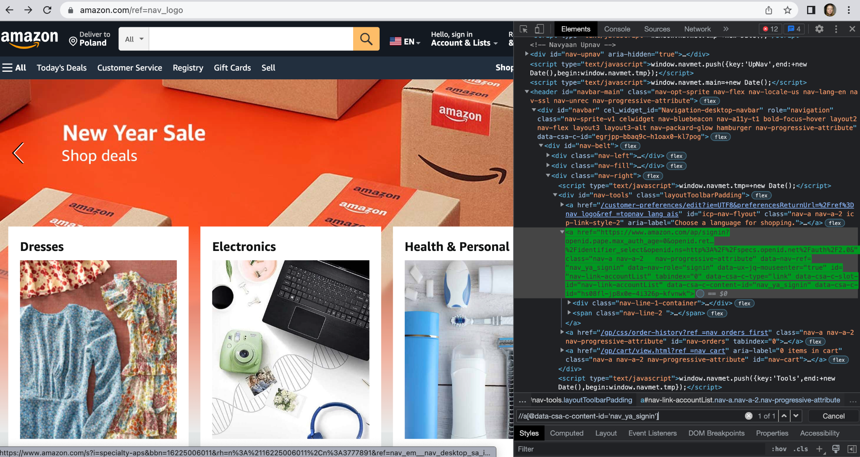

**Returns & Orders menu -**

//a[@id='nav-orders']

//*[@id="nav-orders"]

